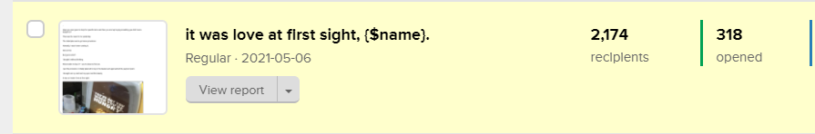
318 people opened this email: https://preview.mailerlite.com/a4y9j7

------------------------------------------------------------------------

Headline: it was love at first sight

———————————————-

Have you ever gone to shop for specific items and then you end up buying something you didn’t even budget for?

That was the case for me yesterday.

The initial plan was to get some provisions.

Honestly, I wasn’t even craving it.

Not one bit.

But guess what?

I bought it without thinking once.

What made me buy it? - you’re about to find out.

I put the provisions I initially planned to buy in the basket and approached the payment point.

I brought out my card and my eyes met this beauty.

It was an instant ‘love at first sight.’
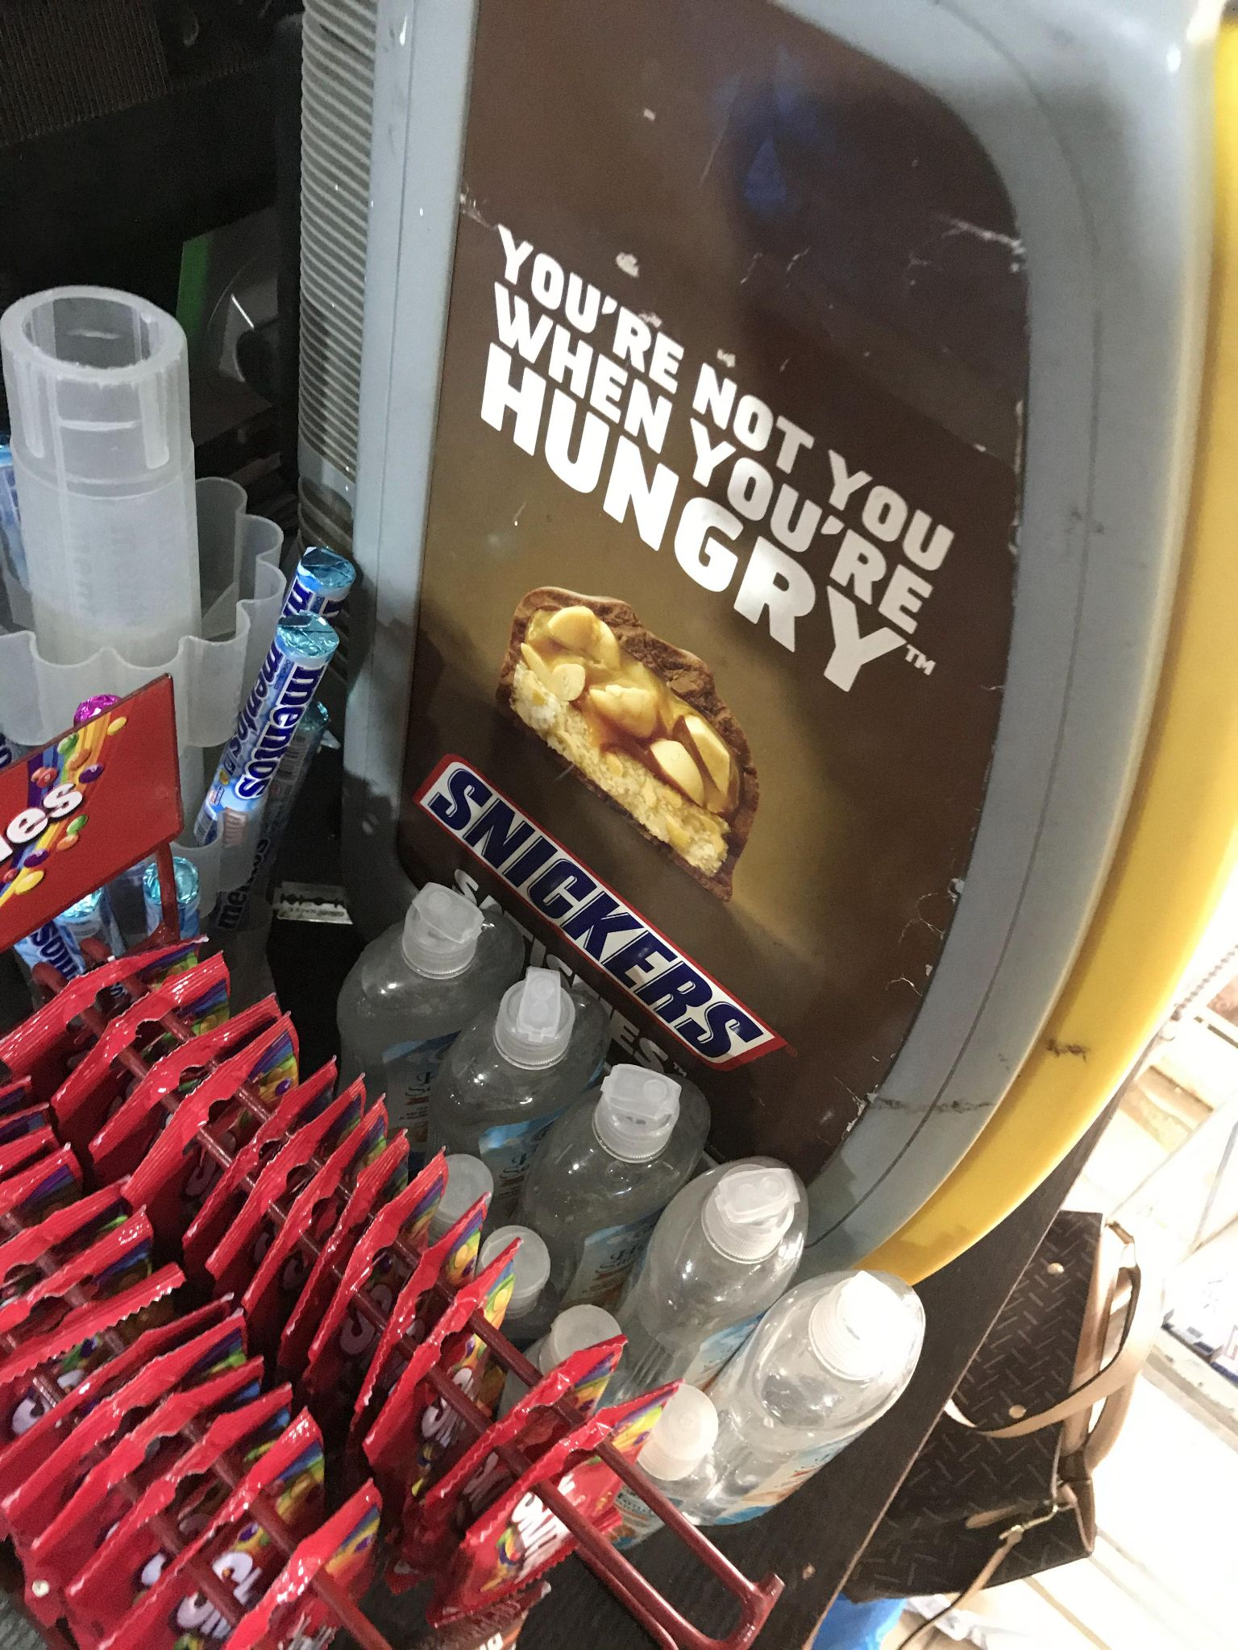

“You’re not you when you’re hungry”

I mean, it’s not a new discovery that you won’t feel at your best when you’re hungry but the way it was communicated almost has no flaws and most importantly, validated what’s in the mind of a hungry person.

Long story longer,

I bought it along with the other items not because I wanted to eat snickers but because they took their time to make me feel seen.

I was hungry no doubt but not for snickers.

In fact - I gave it to the security guard on my way out.

The words you use in describing your products is as important as the product itself. I actually think it’s more important.

Now - this isn’t an excuse to make/sell mediocre products.

The quality of your product should equally match the unignorable words.

As a business owner, when next you purchase a product - find out what made you buy it.

Was it the copy (words)?

Was it the imagery?

Was it the enthusiasm the seller displayed?

What was it?

Henceforth, pay attention!

Have you ever bought something you didn’t budget for along with other things? What made you buy it?

Lamide.

900211, Nigeria

